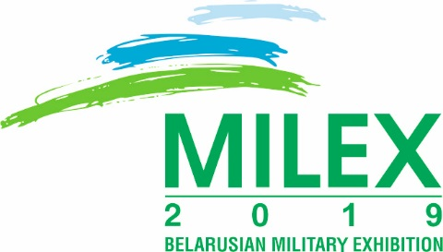
9th INTERNATIONAL EXHIBITION

OF ARMS AND MILITARY MACHINERY

May 15 – 18, 2019
Minsk, Belarus

Dear Ladies and Gentlemen!

We would like to invite you to participate in the 9th International Exhibition of Arms and Military Machinery “MILEX-2019” and the 8th International scientific conference on military-technical cooperation in the field of defense and security that will be held in May 15 – 18, 2019 in the pavilion “Minsk-Arena” situated in 111 Pobediteley ave., Minsk, Belarus. The organizers of the exhibition are the National Exhibition Center “BelExpo” under the Presidential Property Management Directorate of the Republic of Belarus, State Military-Industrial Committee and Ministry of Defence of the Republic of Belarus.
In May, 2017 the 8th International Exhibition of Arms and Military Machinery “MILEX-2017” was held in Minsk. More than 170 enterprises, scientific-research institutes, higher educational establishments, trade firms and companies as well as 14 foreign representative offices accredited in the Republic of Belarus took part in the exhibition.
More than 55 thousand people including more than 12 thousand specialists occupied in the sphere of defense visited the 8th International Exhibition of Arms and Military Machinery. The exhibition was also visited by official foreign delegations from more than 40 countries.
The work of the exhibition was reported by journalists from 167 periodicals, TV-channels, information agencies, radio-channels.
The main thematic content of the 9th International Exhibition of Arms and Military Machinery “MILEX – 2019” is:

ARMS AND MILITARY MACHINERY
- Armored machinery
- Missile, artillery and shooting arms
- Short- and medium-range air defense systems
- Hi-tech equipment and systems
- Ammunition, special chemistry, ground measuring equipment
- Optic-electronic equipment and systems
- Safety methods and security facilities (radiation and chemical protection, biological shielding)
- Technical means and systems provided for armies
- Information systems and systems for information protection
- Transport means: automobiles and tractors
- Aviation, rocket and extraterrestrial complexes. Aerospace technologies
- Aircraft navigation complexes and automatic control systems
- Technologies and technical equipment of double application
- Road, building, loading means and mechanisms
- Modernization and repair of military machinery and arms
- Equipment and technologies for utilization of armament, military machinery and ammunition
- Military establishments of higher education and military training establishments
- Equipment for salvage operations in the conditions of natural calamities and emergency situations, fire-extinguishing equipment and means
- Military medicine
- Military research basis
- Ammunition, clothes and special accessories
- Individual armored equipment

SYSTEM OF ANTI-TERRORISM PROTECTION OF OBJECTS, "SAFE CITY"
- engineering structures and fences
- engineering barriers
- systems and means of security alarm, access control
- systems of videosurveillance, fire detection and extinguishing systems
- communication systems and means
- systems for warning, lighting and protection of objects

SPECIAL TECHNICAL SYSTEMS OF LAW-ENFORCEMENT AUTHORITIES AND SPECIAL SERVICES
- non-aviate weapon, means of restraint of mobility
- antiterrorism equipment
- means of armor protection, equipment
- special vehicles
- search-screening equipment

PREVENTION OF ACCIDENTS, CATASTROPHES AND LIQUIDATION OF THEIR CONSEQUENCES
- monitoring and prediction of earthquakes, mudflows, floods
- equipment for rescue on the water
- automatic fire-extinguishing systems
- evacuation systems
- medical means of emergency relocation of victims
- rescue vehicle
- special medical transport
- fire and sanitary aviation
The main goal of the exhibition is a broad presentation of the products of the belarusian military industry, introduction of new developments in the field of high technologies, demonstration the possibilities of the companies engaged in the modernization and repair of military equipment, providing services to the Armed Forces.
The organizers of the 9th International Exhibition of Arms and Military Machinery “MILEX – 2019” and the 8th International scientific conference on military-technical cooperation in the field of defense and security are ready to hold this event at a high professional level.

In case you have any questions concerning the participation or attending the exhibition, please, contact the project manager –Sergey Rubtsov
Tel +375 17 237 71 18,
Fax +375 17 237 71 18,
e-mail: milex@belexpo.by.
http// www.milex.belexpo.by

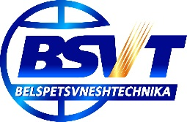
General partner - BELSPETSVNESHTECHNIKA

